2023 Chafer Conference
Genesis 5 and 11 Resource Links
- These seven YouTube videos along with their transcriptions are available.

- Primeval Chronology Revisited: Genesis 5 and 11 and Their Potential Impact on Biblical Archaeology
https://www.youtube.com/watch?v=mpZg-jTpwio&t=16s
Transcript: DOCX PDF
- On the Authenticity of Kainan (Luke 3:36; Genesis 11)
https://www.youtube.com/watch?v=y15s5bqRZrc
Transcript: DOCX PDF
- The Case for the Septuagint’s Chronology in Genesis 5 and 11, dated Oct 1, 2021.
https://www.youtube.com/watch?v=k5EtBuReU0s&list=PL0QKHh_IUzjFgygbLSKdWcJ4nDnD-Nmst&index=7
Transcript: DOCX PDF
- Primeval Chronology: A Hermeneutical, Exegetical, and Textual Sketch
https://www.youtube.com/watch?v=gVZGY4tRubs
Transcript: DOCX PDF
- On the Originality of the Septuagint’s Numbers in Genesis 5 and 11
https://www.youtube.com/watch?v=-QwNxySf0C8&t=2s
Transcript: DOCX PDF
- An Exegetical Examination of the Genealogies of Genesis 5 and 11
https://www.youtube.com/watch?v=n8MOABkdWkw&list=PL0QKHh_IUzjFgygbLSKdWcJ4nDnD-Nmst&index=5
Transcript: DOCX PDF
- The Primeval Chronology of the Septuagint: An Overview
https://www.youtube.com/watch?v=ykrWTdUI4AQ
Transcript: DOCX PDF
Another YouTube video
Jun 24, 2016 Jeremy Sexton
Jeremy Sexton on The Genesis Genealogy in Chapters 5 & 11
https://www.youtube.com/watch?v=I_A2DINkwuI

- For additional reading:
- Smith Jr., Henry B., “Methuselah’s Begetting Age in Genesis 5:25 and the Primeval Chronology of the Septuagint: A Closer Look at the Textual and Historical Evidence.” Answers Research Journal 10 (2017): 169–79.
- Cosner, Lita and Robert Carter, “Textual traditions and biblical chronology,” Journal of Creation 29(2) 2015. https://creation.com/images/pdfs/tj/j29_2/j29_2_99-105.pdf
Response to this by Smith:
https://biblearchaeology.org/research/topics/biblical-chronologies/4767-from-adam-to-abraham-the-latest-on-the-genesis-5-and-11-project
https://biblearchaeology.org/images/Genesis-5-and-11/Setting-the-Record-Straight-Cosner-Carter-Response-Fall-2018-BAS.pdf

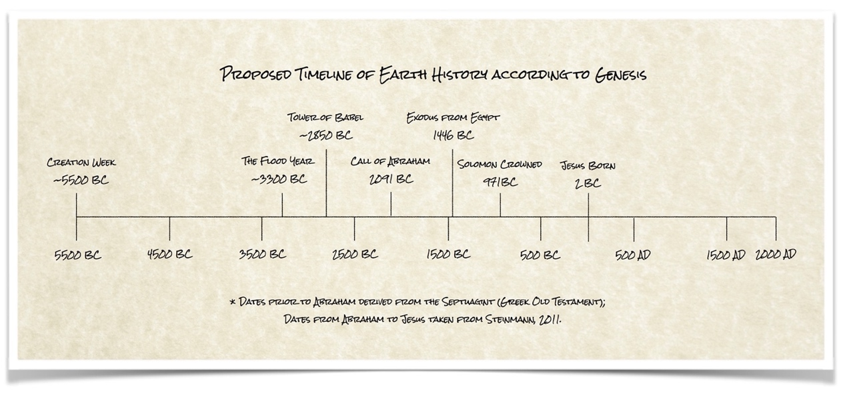
- Key articles
- Sexton, Jeremy. "Who Was Born When Enosh Was 90?: A Semantic Reevaluation of William Henry Green's Chronological Gaps." The Westminster Theological Journal 77, no. 2 (September 2015): 193-218.
- *Sexton, Jeremy and Henry B. Smith Jr. " Primeval Chronology Restored: Revisiting the Genealogies of Genesis 5 and 11." Bible and Spade, 29, no. 2 (Spring/Summer 2016): 42-49. Excellent article, fundamental to understand all of the data not covered in the video presentation “On the Originality of the Numbers in the Septuagint”
- Smith Jr., Henry B., “From Adam to Abraham: An Update on the Genesis 5 and 11 Research Project.” Associates for Biblical Research, April 26, 2017.
- *Smith Jr., Henry B., “Methuselah’s Begetting Age in Genesis 5:25 and the Primeval Chronology of the Septuagint: A Closer Look at the Textual and Historical Evidence.” Answers Research Journal 10 (2017): 169–79.
- Smith Jr., Henry B., "MT, SP, or LXX? Deciphering a Textual and Chronological Conundrum in Genesis 5," Bible and Spade, no. 1 (Winter 2018): 18-27.
- Sexton, Jeremy, “Evangelicalism’s Search for Chronological Gaps in Genesis 5 and 11: A Historical, Hermeneutical, and Linguistic Critique,” Journal of the Evangelical Theological Society 61, no. 1 (2018): 5–25.
- Sexton, Jeremy, “Andrew E. Steinmann’s Search for Chronological Gaps in Genesis 5 and 11: A Rejoinder,” Journal of the Evangelical Theological Society 61, no. 1 (2018): 39–45.
- Smith Jr., Henry B., “A Report on the Genesis 5 and 11 Research Project.” Associates for Biblical Research, July 27, 2018.
- Smith Jr., Henry B., "The Case for the Septuagint's Chronology in Genesis 5 and 11," In Proceedings of the Eighth International Conference on Creationism (2018), ed. J.H. Whitmore, pp. 117–132. Pittsburgh, Pennsylvania: Creation Science Fellowship.
- Smith Jr., Henry B., "New Evidence for Kainan in New Testament and LXX Papyri," Bible and Spade 31, no. 3 (Summer 2018): 70-77.
- *Smith Jr., Henry B., “Setting the Record Straight on the Primeval Chronology of the Septuagint: A Response to Cosner and Carter.” Bible and Spade 31, no. 4 (Fall 2018): 114–133.
- Smith Jr., Henry B. and Kris J. Udd., "On the Authenticity of Kainan, Son of Arpachshad." Detroit Baptist Seminary Journal 24 (2019): 119-154.
- Smith Jr., Henry B., "By Whose Authority?" Bible and Spade 33, no. 4 (Fall 2020): 10-11.
- Smith Jr., Henry B., "From Adam to Abraham: The Latest on the Genesis 5 and 11 Project." Associates for Biblical Research, January 14, 2021.
- Smith Jr., Henry B., "Wild West Evangelical Hermeneutics (Part One): The Failure of Comparative Archaeological Method." Bible and Spade 34.3 (Summer 2021): 22-28.
- Smith Jr., Henry B., "Wild West Evangelical Hermeneutics (Part Two): Jesus Christ and the Supreme Authority of Scripture." Bible and Spade 34.4 (Fall 2021): 25-32.
- Smith Jr., Henry B., "Wild West Evangelical Hermeneutics (Part Three): The Patriarchal Lifespans." Bible and Spade (Spring 2022) (forthcoming).

- Articles critiquing the LXX over MT view
“Jonathan Sarfati, “Biblical chronogenealogies” TJ 17(3) 2003 https://creation.com/images/pdfs/tj/v17n3_chronogenealogies.pdf This is an overview article which came out in 2003 before a lot of the current debate developed.
Cosner, Lita and Robert Carter, “Textual traditions and biblical chronology,” Journal of Creation 29(2) 2015. https://creation.com/images/pdfs/tj/j29_2/j29_2_99-105.pdf
__________________. “Is the Septuagint a superior text for the Genesis genealogies? “25 Sept 2018. https://creation.com/lxx-mt-response A response to the arguments set forth by Henry B. Smith.
__________________. “The Masoretic text of Genesis 5 and 11 is still the most reliable, 4 June 2019. https://creation.com/smith-response
Unknown author. “Why 6,000 years and not Septuagint chronology?” https://creation.com/6000-years-masoretic-vs-lxx
Response to this by Smith:
https://biblearchaeology.org/research/topics/biblical-chronologies/4767-from-adam-to-abraham-the-latest-on-the-genesis-5-and-11-project
https://biblearchaeology.org/images/Genesis-5-and-11/Setting-the-Record-Straight-Cosner-Carter-Response-Fall-2018-BAS.pdf

